## Prohibit access to all external storage, task manager, remove Task manager and properties from computer context menu and Control Panel.
1-prohibit access to all External Storge{CD,DVD,WPD (windows portable devices) ,Remavable devices(Hard or Flash memory)}
2-remove Task manger (ctrl+alt+del)
3-Remove Properties
4-prohibit control Panel.
ايقاف اي ذاكرة تخزين خارجية سواء قراءة او كتابة،حذف التاسك مانجر ،والخصائص والكنترول بانل
=========
1-prohibit access to all External Storge{CD,DVD,WPD (windows portable devices) ,Remavable devices(Hard or Flash memory)}
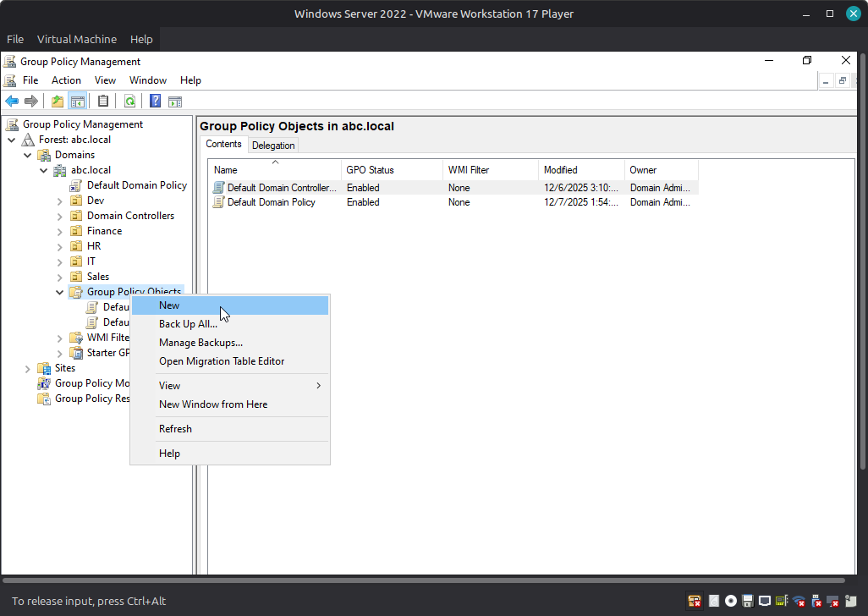

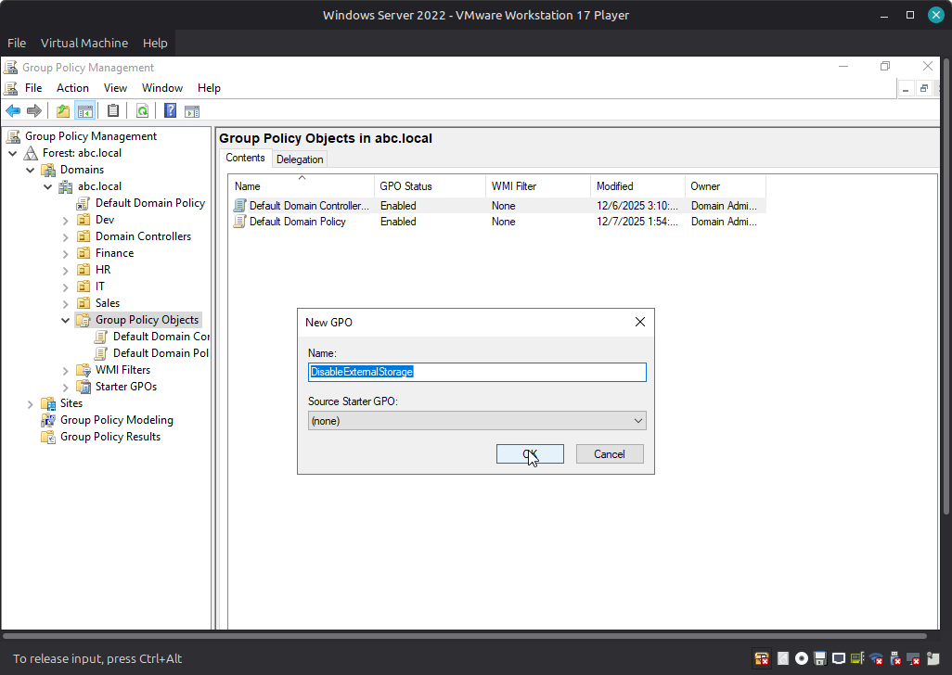

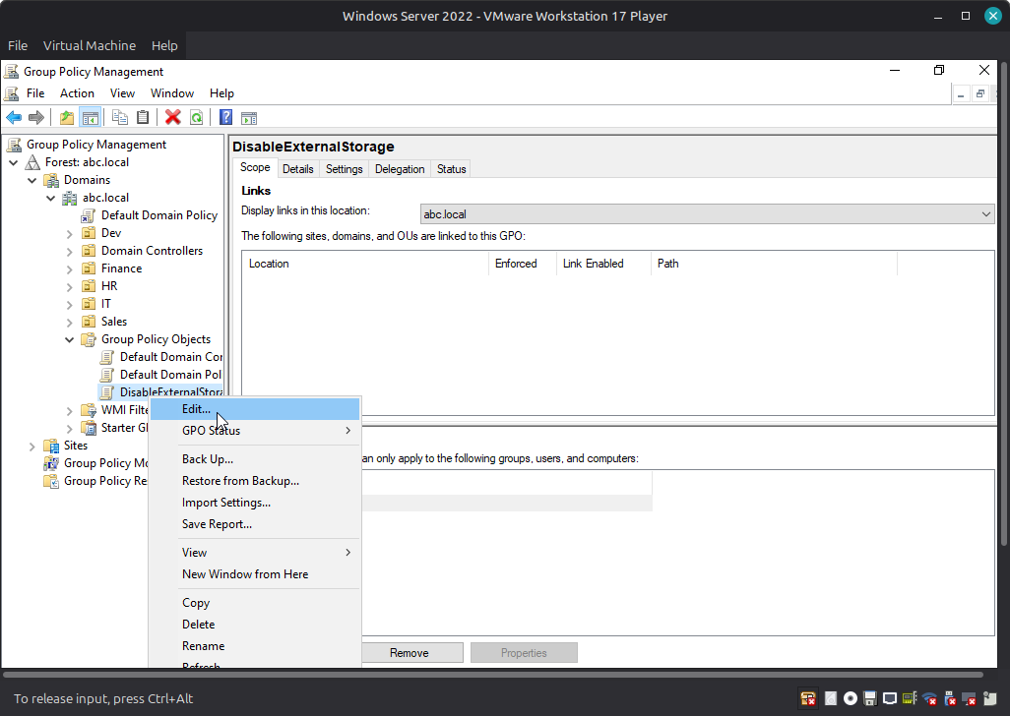

path>>user Configuration >Policies>Administrative Templates :Policy definiation >System>Removable Stroage Access
do this:
1- CD&DVD Deny Read Access ====>Enable
2- CD&DVD Deny Write Access ====>Enable
3-All Removable Storage Classes :Deny All Access =====> Enable
4-WPD Devices:Deny All Read Access =====>Enable
5-WPD Devices:Deny All Write Access =====>Enable
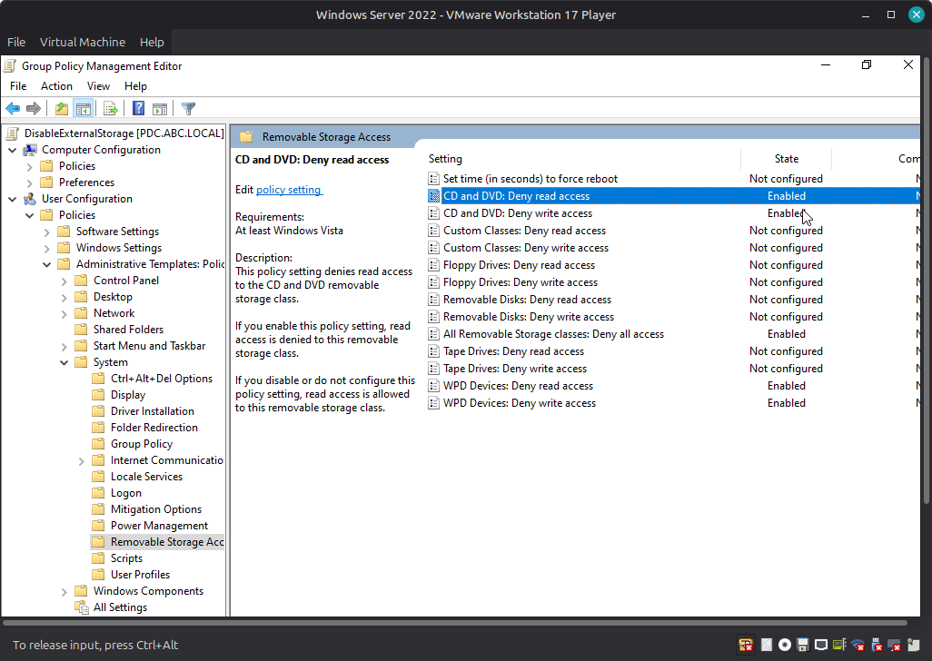
=we Apply this Group Policy on OU of Sales
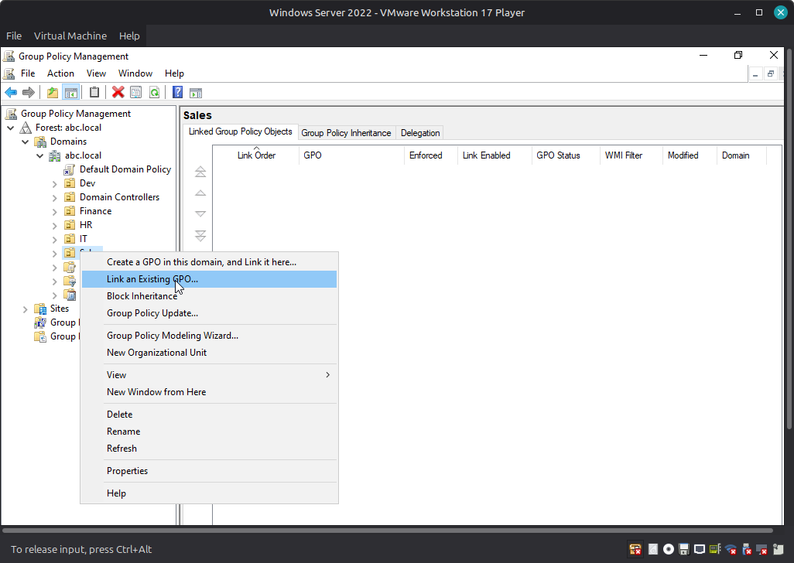
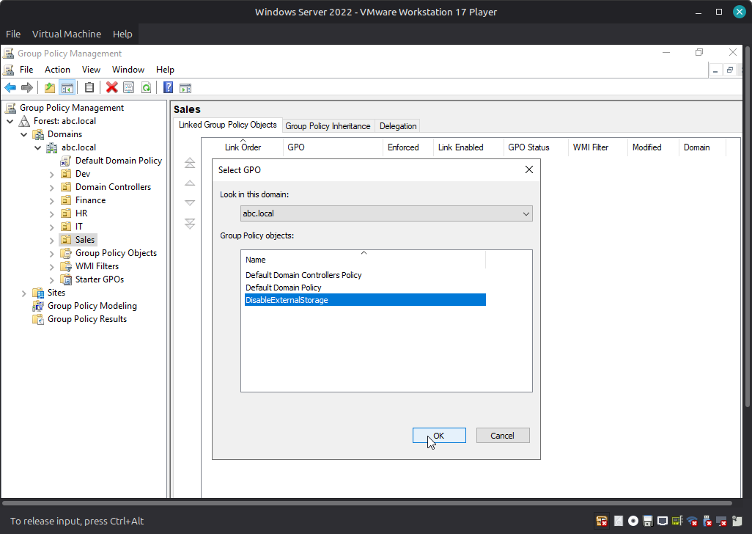

2#Remove Task manger (ctrl+alt+del)
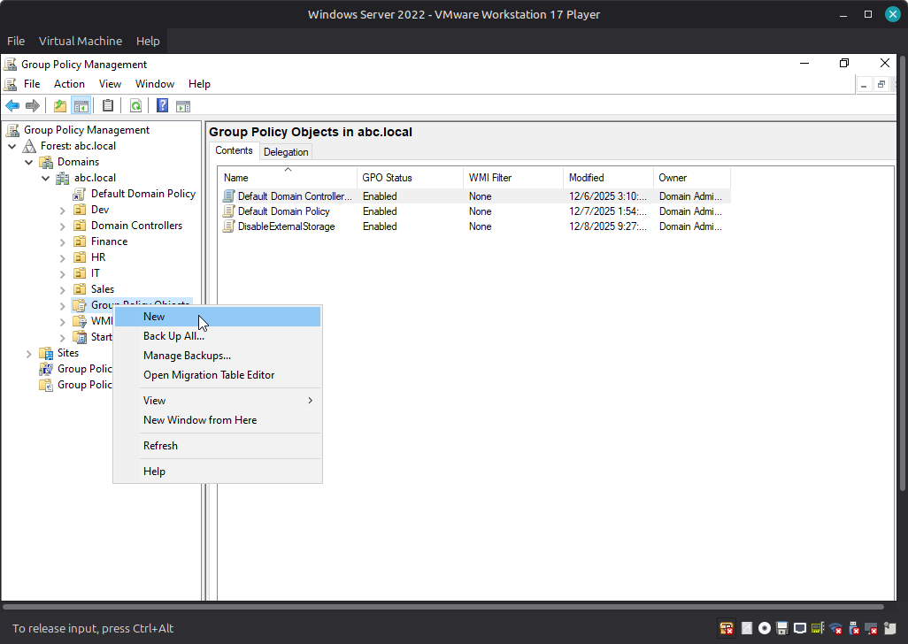
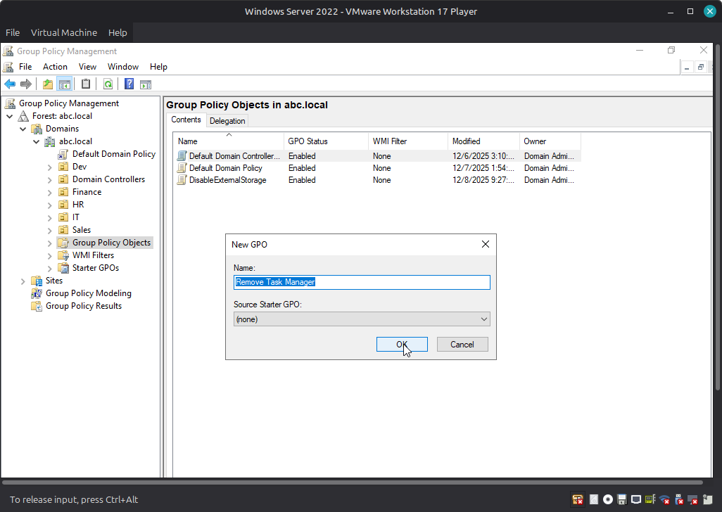

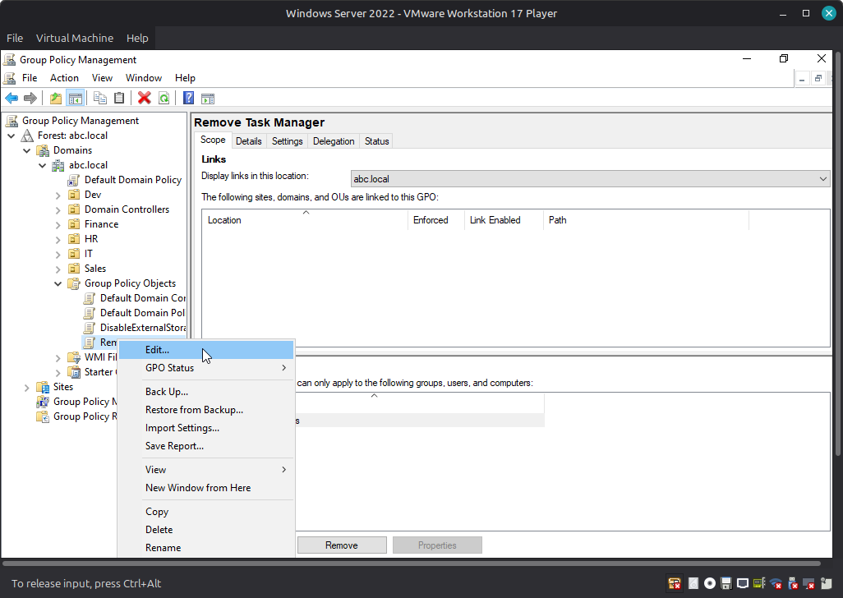
path>>user Configuration >Policies>Administrative Templates :Policy definiation >System> Ctrl+Alt+Del Option

==Remove Task Manger ======> Enable
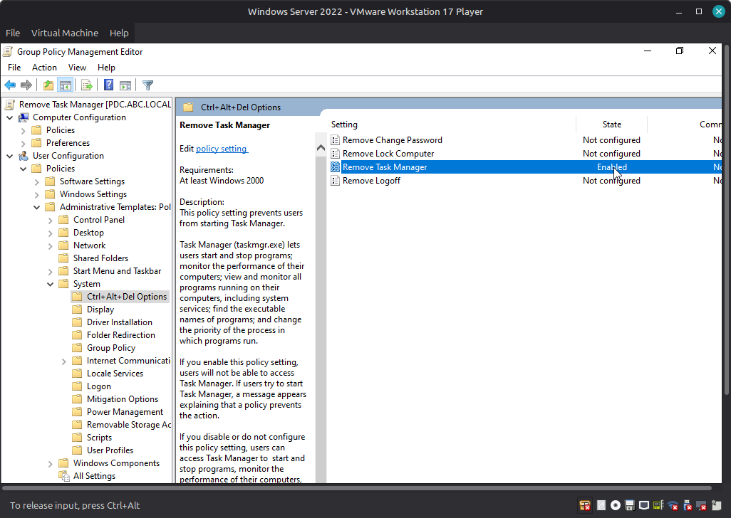

===============
#Remove Properties
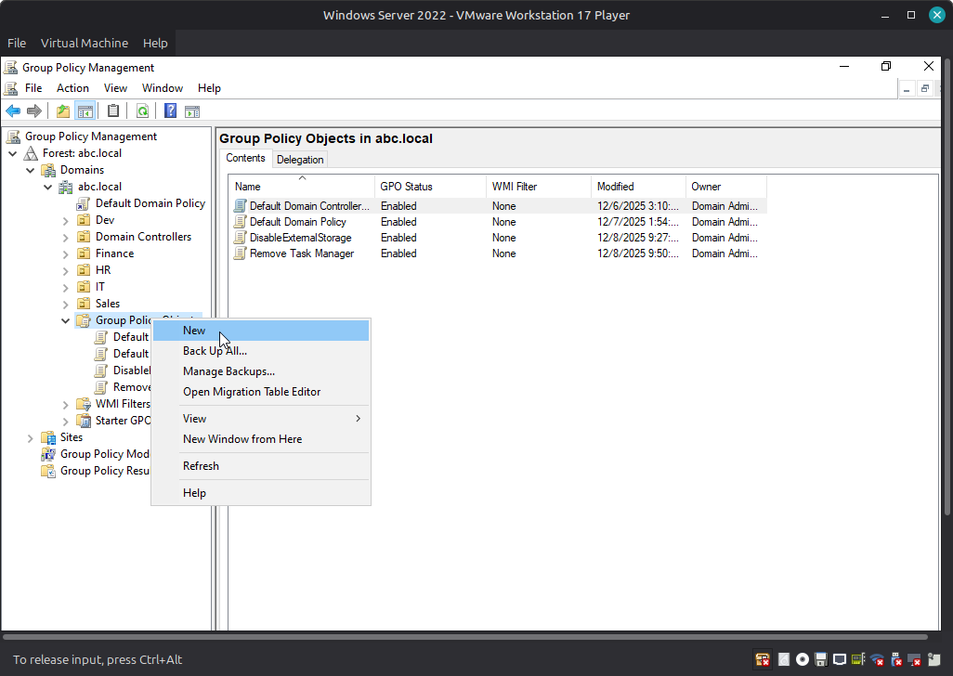

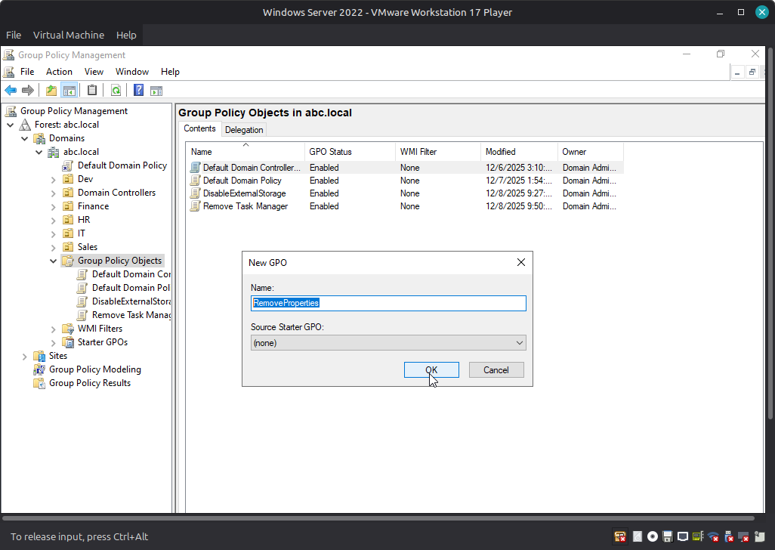
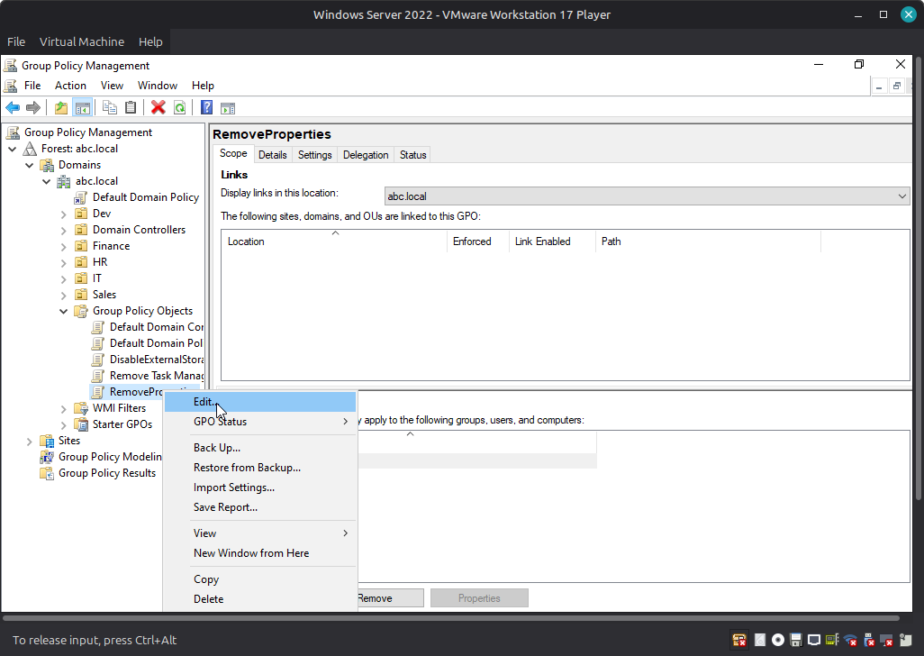

path>>user Configuration >Policies>Administrative Templates :Policy definiation >System> DeskTop

==Remove Properties From Computer Icon Context Menu ======> Enable
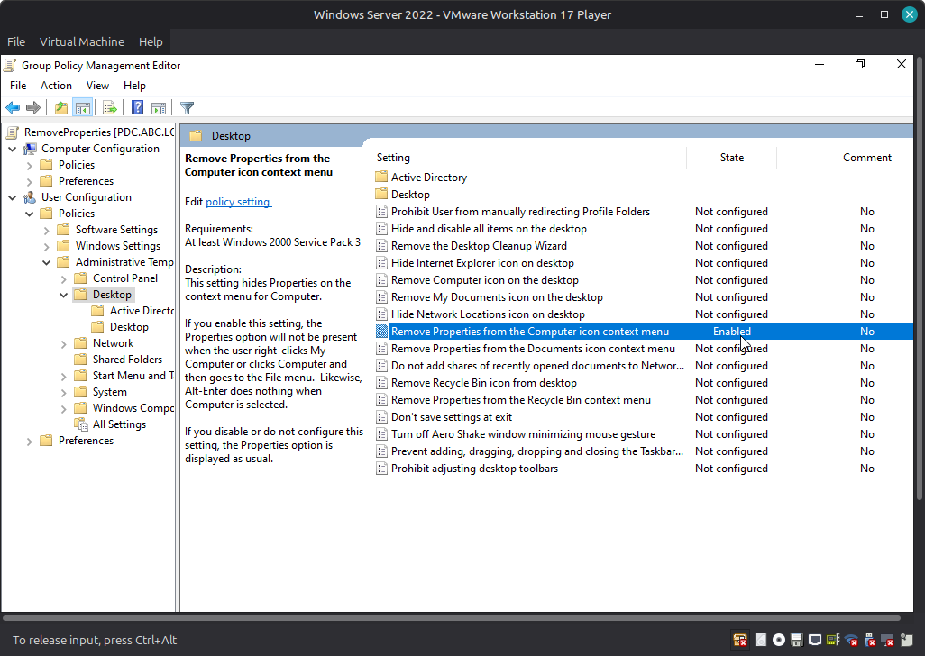

========================
#Prohibit Access To Control Pannel and PC Setting
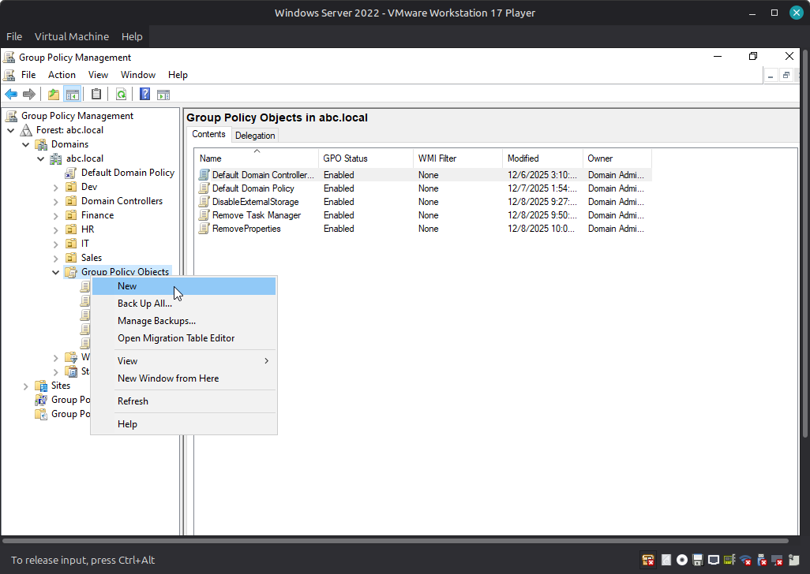
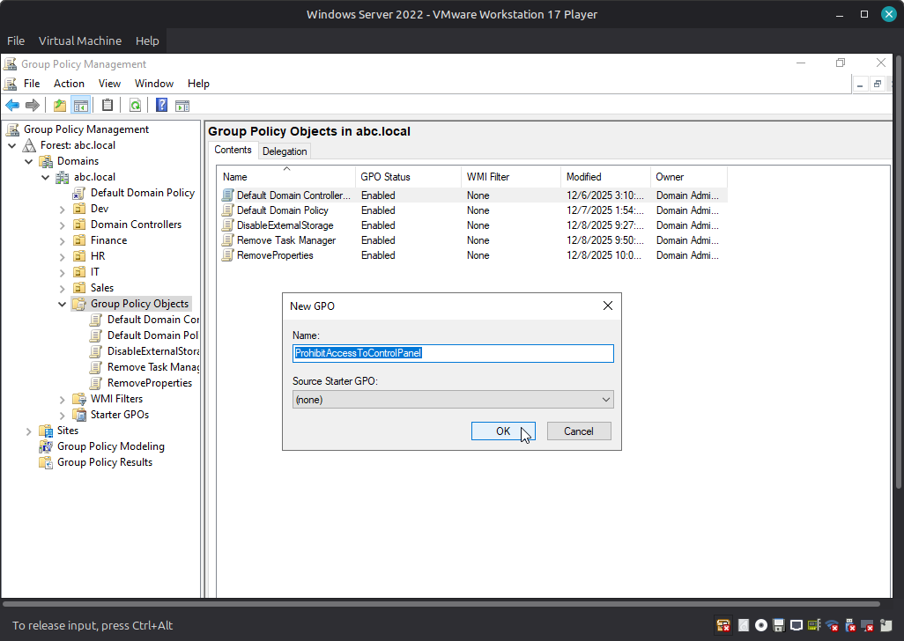

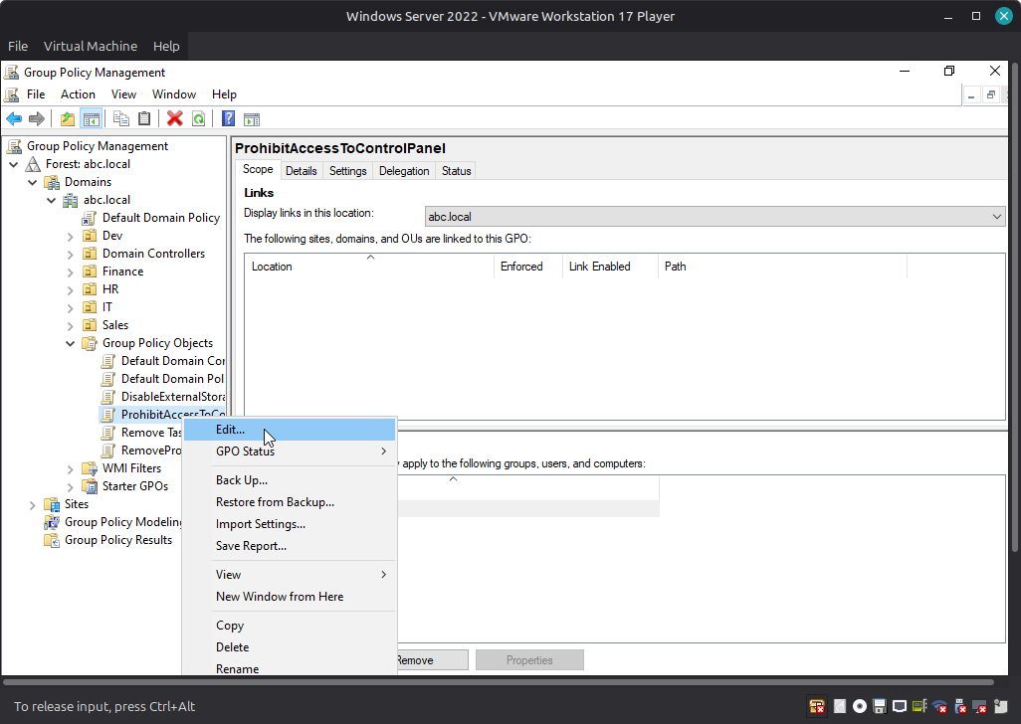
path>>user Configuration >Policies>Administrative Templates :Policy definiation >System> Control Panel

==Prohibit access control panel and pc settings ======>Enable
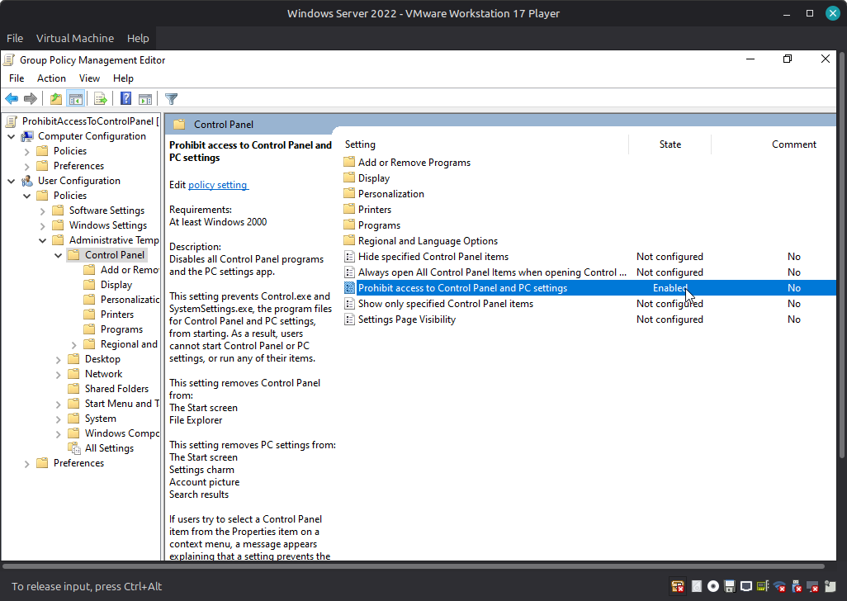

=We Finshed this Task

